Homework 11

STAT 4025/5025 – Due Wednesday, May 4th 11:00 pm 44 points 4025 / 48 for 5025

1. An experiment is to be conducted to compare 4 cooking temperatures and 3 mixtures of alloys on strength measurements of steel rods. The cooking period is 2 hours, so that only 4 cooking periods can be conducted on a business day (the temperatures are randomly assigned to periods). The experimenter decides she will assign the 3 mixtures at random to the 3 positions in the oven (experience implies there are no position effects), separately for the 4 runs on a given day. She repeats the experiment over 3 days (randomizing separately on each day). Her assistant provides her the following sequences of random numbers for temperature and mixtures – using the random numbers, she decides the highest numbers go first. [14 pts]
   1. Give the assignment of treatments to experimental positions (in each cell, enter Ti/Mj where i=Temperature level, j=Mixture level). [10 pts]

|  |  |  |  |  |  |  |  |  |  |  |  |  |  |
| --- | --- | --- | --- | --- | --- | --- | --- | --- | --- | --- | --- | --- | --- |
|  |  | Day 1 | | | | Day 2 | | | | Day 3 | | | |
| Tem p | 1 | 2 | 3 | 4 | 1 | 2 | 3 | 4 | 1 | 2 | 3 | 4 |
| Ran# | 0.96 | 0.91 | 0.16 | 0.22 | 0.21 | 0.34 | 0.28 | 0.27 | 0.75 | 0.23 | 0.37 | 0.20 |
|  | | | | | | | | | | | | | |
|  |  | Period 1 | | | Period 2 | | | Period 3 | | | Period 4 | | |
| Day 1 | Mix | 1 | 2 | 3 | 1 | 2 | 3 | 1 | 2 | 3 | 1 | 2 | 3 |
| Ran# | 0.10 | 0.54 | 0.58 | 0.59 | 0.70 | 0.79 | 0.26 | 0.74 | 0.72 | 0.83 | 0.17 | 0.56 |
| Day 2 | Mix | 1 | 2 | 3 | 1 | 2 | 3 | 1 | 2 | 3 | 1 | 2 | 3 |
| Ran# | 0.29 | 0.64 | 0.43 | 0.76 | 0.65 | 0.56 | 0.97 | 0.28 | 0.06 | 0.83 | 0.76 | 0.64 |
| Day 3 | Mix | 1 | 2 | 3 | 1 | 2 | 3 | 1 | 2 | 3 | 1 | 2 | 3 |
| Ran# | 0.91 | 0.55 | 0.83 | 0.43 | 0.69 | 0.19 | 0.98 | 0.79 | 0.36 | 0.26 | 0.78 | 0.11 |

|  |  |  |  |  |  |  |  |  |  |
| --- | --- | --- | --- | --- | --- | --- | --- | --- | --- |
|  | Day1 | Day1 | Day1 | Day2 | Day2 | Day2 | Day3 | Day 3 | Day 3 |
|  | Pos1 | Pos2 | Pos3 | Pos1 | Pos2 | Pos3 | Pos1 | Pos2 | Pos3 |
| Pe r1 | T1 M3 | T1 M2 | T1 M1 | T2 M2 | T2 M3 | T2 M1 | T1 M1 | T1 M3 | T1 M2 |
| Pe r2 | T2 M3 | T2 M2 | T2 M1 | T3 M1 | T3 M2 | T3 M3 | T3 M2 | T3 M1 | T3 M3 |
| Pe r3 | T4 M2 | T4 M3 | T4 M1 | T4 M1 | T4 M2 | T4 M3 | T2 M1 | T2 M2 | T2 M3 |
| Pe r4 | T3 M1 | T3 M3 | T3 M2 | T1 M1 | T1 M2 | T1 M3 | T4 M2 | T4 M1 | T4 M3 |

* 1. What is the name of this design? Explain. [4 pts for name, 6 pts for correct explanation]

This is a Split Plot Design. The block is the Day whereas the whole plot is the Period. The subplot is position. The whole plot is treated with temperatures and the subplot is treated with the mixture.

1. The file laundry.csv contains data from an experiment that was conducted to determine the impact of wool treatment (1- untreated, 2- 15 seconds alcoholic potash, 3- 5 minutes alcoholic potash, and 4- 10 minutes alcoholic potash) and drying cycle speed (200 revolutions/minute – 1400 revolutions/min) on the percent of shrinkage in a wool fabric. There were 4 dryers available for the study.A total of 16 pieces of wool were available for the study – 4 were untreated, 4 were exposed to 15 seconds of alcoholic potash, 4 were exposed to 5 minutes of alcoholic potash and 4 were exposed to 10 minutes of alcoholic potash. Each dryer was randomly assigned one piece of wool from each of the wool treatment groups. After this assignment, each piece of wool was cut into 7 strips – 28 stripsavailable for each dryer.
   1. Determine if there is a difference in mean percent shrinkage among the four wool treatment types using output from the lm() function. Write your hypotheses. Provide the appropriate test statistic value and determine your p- value [6 pts – 2 for hypotheses, 2 for test statistic and 2 for the p-value].

𝐻!: 𝜇" = 𝜇# = 𝜇$ = 𝜇% 𝑣𝑠 𝐻&: 𝐴𝑡 𝑙𝑒𝑎𝑠𝑡 𝑜𝑛𝑒 𝜇 𝑖𝑠 𝑑𝑖𝑓𝑓𝑒𝑟𝑒𝑛𝑡 𝑓𝑜𝑟 𝑖 = 1,2,3,4

𝑇𝑒𝑠𝑡 𝑠𝑡𝑎𝑡𝑖𝑐𝑡𝑖𝑐: 𝑀𝑆(𝑇𝑟𝑒𝑎𝑡𝑚𝑒𝑛𝑡)

𝑀𝑆(𝑇𝑟𝑒𝑎𝑡𝑚𝑒𝑛𝑡 + 𝑀𝑎𝑐ℎ𝑖𝑛𝑒)

𝑝 − 𝑣𝑎𝑙𝑢𝑒 = 2.2 e-16

= 1004.18 = 78.84

12.72

* 1. Repeat your test from part A but use the lmer() function. Simply show the appropriate output and show that your test statistic value is the same as it is in part A. [2 pts]

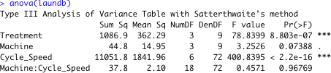

F = 78.84

* 1. Produce the treatment*cycle speed interaction plot with cycle speed on the horizontal axis. [3 pts]

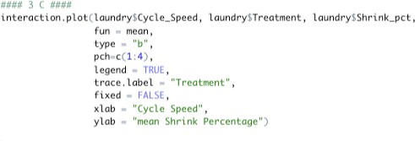

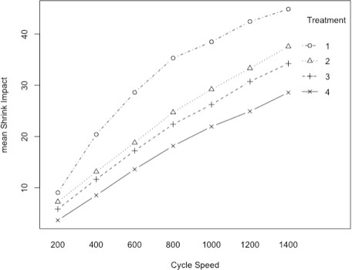

* 1. Write out the betas associated with the mean shrinkage percentage for treatment 1 at a cycle speed of 1400 RVM. Do the same for mean shrinkage percentage for treatment 2 at a cycle speed of 1400 RVM. [4 pts].

𝑇' = 𝑇𝑟𝑒𝑎𝑡𝑚𝑒𝑛𝑡, 𝑀( = 𝑀𝑎𝑐ℎ𝑖𝑛𝑒, 𝑆) = 𝑆𝑝𝑒𝑒𝑑 𝑜𝑓 𝐶𝑦𝑐𝑙𝑒

𝑌"!",.%.,&"'(( = 𝛽( + 𝛽%) + 𝛽%* + 𝛽%' + 𝛽&"'(( + 𝛽%)&"'(( + 𝛽%*&"'(( + 𝛽%'&"'(( + 𝜀+,-

𝑌"!),.%.,&"'(( = 𝛽( + 𝛽!) + 𝛽%) + 𝛽%* + 𝛽%' + 𝛽&"'(( + 𝛽!)%)&"'(( + 𝛽!)%*&"'(( + 𝛽!)%'&"'(( + 𝜀+,-

* 1. Provide a 95% confidence interval for the difference in mean shrinkage percentage between treatment 1/1400 RVM and treatment 2/1400 and interpret your interval. [4 pts- 2 pts for correct R and 2 pts for correct interpretation].

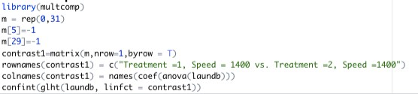

𝑌"!",.%.,&"'(( − 𝑌"!),.%.,&"'(( = − 𝛽!) − 𝛽!),,&"'((

[4.8995, 9.7005]

We are 95% confident that the mean shrinkage percentage difference between Treatments 1 and 2 at the speed of 1400 RPM is between 4.9% and 9.7%.

1. An experiment was conducted to study the efficacy of five different pesticides upon the yield of corn. Ten Nebraska farms were identified for participation and each farm set aside 5 one-acre plots for application of the pesticides (1 pesticide on each plot). Pesticides were randomly assigned to each of the five one acre plotson each farm. The partially completed ANOVA table from the analysis of this data is below: [11 pts for 4025 and 14 pts for 5025]

|  |  |  |  |  |
| --- | --- | --- | --- | --- |
| Source | Df | SS | MS | F |
| Blocks | 9 | 135 | 15 |  |
| Treatments | 4 | 100 | 25 | 12.5 |
| Residual | 36 | 72 | 2 |  |
| Total | 49 | 307 | 6.27 |  |

1. What is the name of this experimental design? Justify your answer. [2 pts]

This is an RCBD design. We are only randomly assigning the 5 pesticides amongst the 10 experimental Blocks. This gives 50 experimental units.

1. Complete the ANOVA table above. [4 pts]
2. Write the linear model which corresponds to the appropriate analysis of this data.[2 pts]

𝑦'( = 𝜇 + 𝛼'( + 𝛽( + 𝜀'(

1. Determine if there is a significance difference among the means of the five treatments. Be sure to state your hypotheses, provide the test-statistic, computethe p-value and state a conclusion. Use a significance level of 0.05. [3 pts]

𝐻!: 𝜇" = 𝜇# = 𝜇$ = 𝜇% = 𝜇* 𝑣𝑠 𝐻&: 𝐴𝑡 𝑙𝑒𝑎𝑠𝑡 𝑜𝑛 𝜇 𝑖𝑠 𝑑𝑖𝑓𝑓𝑒𝑟𝑒𝑛𝑡

𝐹+,-./0-1/ = 12.5



Conclusion: P-value < .05. We have significant evidence to conclude that there is a difference of means in treatments.